Prisoner’s Dilemma: <https://youtu.be/iZKErrvVMaY>

What Is a Nash Equilibrium? <https://youtu.be/5TcYV6CZ7mI>

What Is a Nash Equilibrium? (Stoplight Game) : <https://youtu.be/0i7p9DNvtjk>

Battle of the Sexes [BOS] <https://youtu.be/2BdBWmL8tJc>

How to calculate Pay-offs : <https://youtu.be/4lEl4vDkML8>

Pure Strategy Nash Equilibrium and the Stag Hunt : <https://youtu.be/stzPcqmyhI4>

Mixed Strategy Nash Equilibrium and Matching Pennies <https://youtu.be/fvEQujUcPv4>

Mixed Strategy Nash Equilibrium (how to solve Problem): <https://youtu.be/0w_r7lkmEvc>

Strict Dominance in Mixed Strategies : <https://youtu.be/3dd-IRedU0U>

(Non-strict) Weak Dominance: <https://youtu.be/OlV190noZOw>

Sums: <https://www.thelearningpoint.net/home/mathematics/an-introduction-to-game-theory>

Oligopoly models:

<https://www.studysmarter.co.uk/explanations/microeconomics/imperfect-competition/cournot-model/>

<https://www.studysmarter.co.uk/explanations/microeconomics/imperfect-competition/bertrand-competition/>

Nash equilibrium:

<https://www.investopedia.com/terms/n/nash-equilibrium.asp#:~:text=Nash%20equilibrium%20states%20that%20nothing,the%20other%20players%20have%20chosen>.

# Prisoner's Dilemma

<https://www.investopedia.com/terms/p/prisoners-dilemma.asp>

Matching pennies:

<https://www.investopedia.com/terms/m/matching-pennies.asp>

8 QUEEN PROBLEM:

[8-Puzzle Problem in Artificial Intelligence without Heuristic | All Imp Points | Must Watch](https://youtu.be/_CrEYrcImv0)

[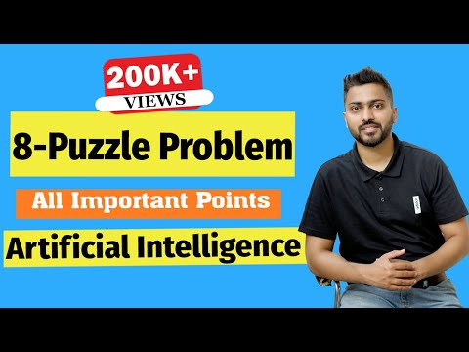](https://youtu.be/_CrEYrcImv0)

# **Uninformed Vs Informed Search in Artificial Intelligence with Example**

[Uninformed Vs Informed Search in Artificial Intelligence with Example](https://youtu.be/gZpUcsB9TFc)

[](https://youtu.be/gZpUcsB9TFc)

# **Introduction to Intelligent Agents and their types with Example in Artificial Intelligence**

[Introduction to Intelligent Agents and their types with Example in Artificial Intelligence](https://youtu.be/BkedAnQfJ_U)

[](https://youtu.be/BkedAnQfJ_U)

Game strategies:

[Can You Solve The 6 Cards Game?](https://youtu.be/tv9HjFyGPgc)

[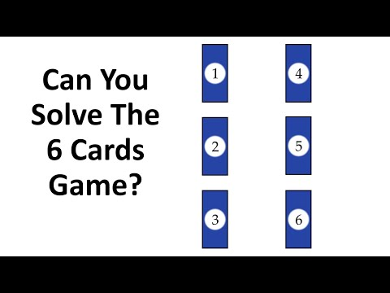](https://youtu.be/tv9HjFyGPgc)

[Here we go again. What is the missing length?](https://youtu.be/rGt1VZ9Yb38)

[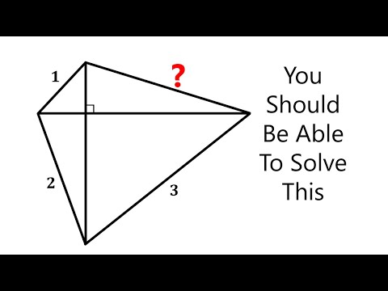](https://youtu.be/rGt1VZ9Yb38)

[What is the volume when you fold this into a box?](https://youtu.be/LINriC_R_bY)

[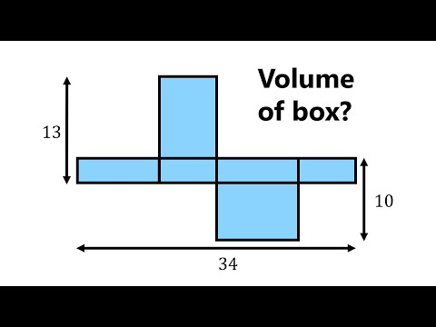](https://youtu.be/LINriC_R_bY)

[Magical Triangle - Think Outside The Box!](https://youtu.be/o1qiKJfe_3w)

[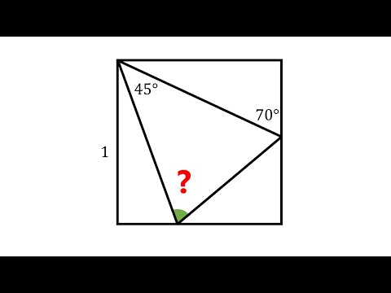](https://youtu.be/o1qiKJfe_3w)

<https://www.futurelearn.com/courses/artificial-intelligence>